1. Configuration of Network device using package tracer (Hub, Switch , Ethernet, Broadcast)

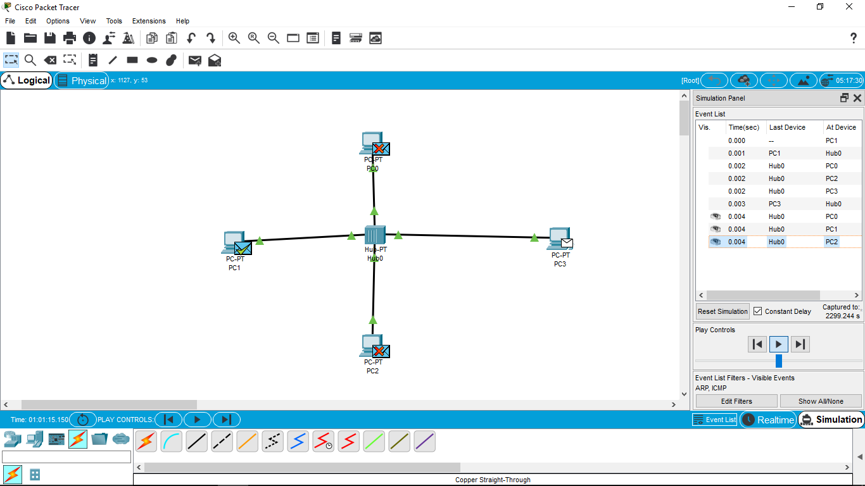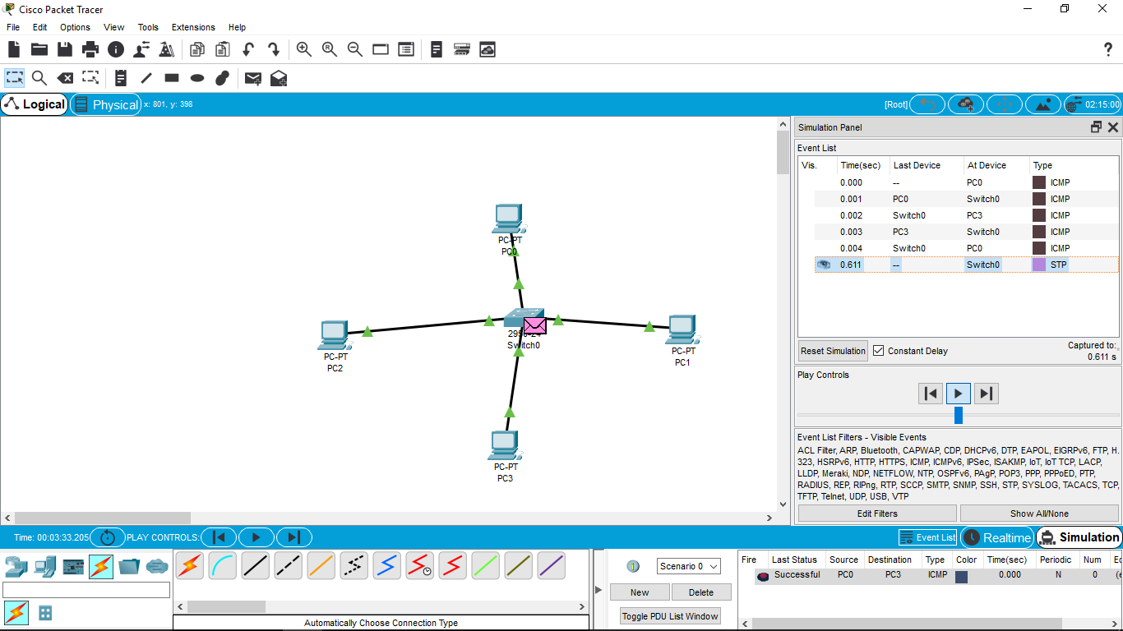

1. Configuration of Topologies using package tracer (Star, Mesh, Tree, Bus, Ring, hybrid)

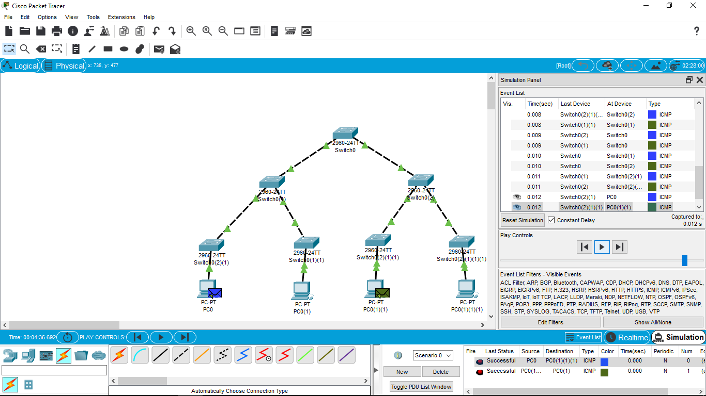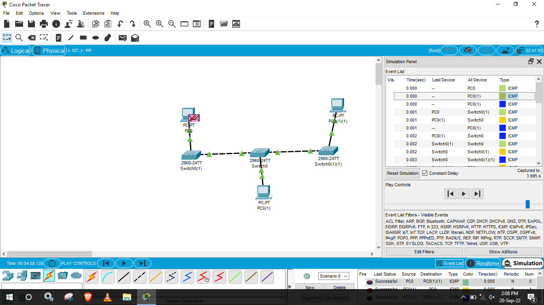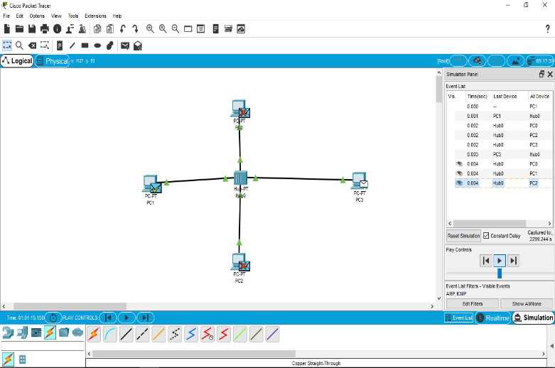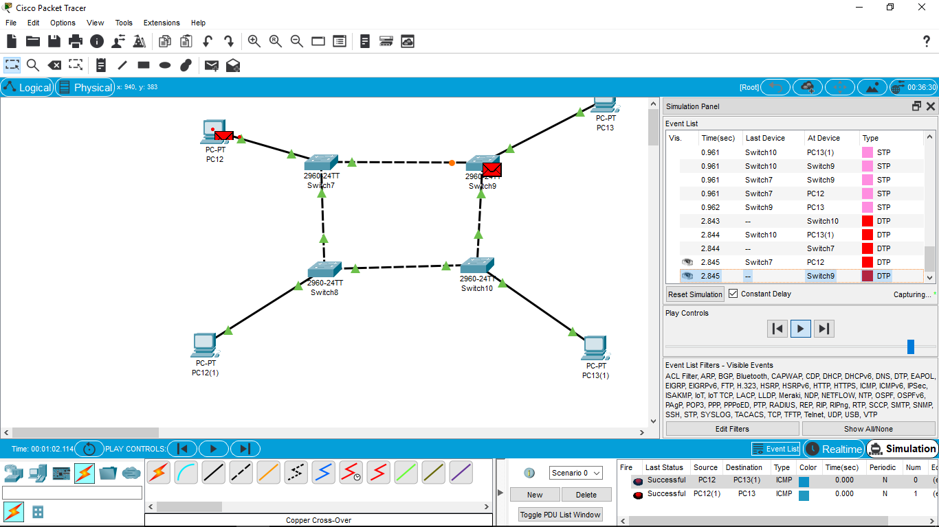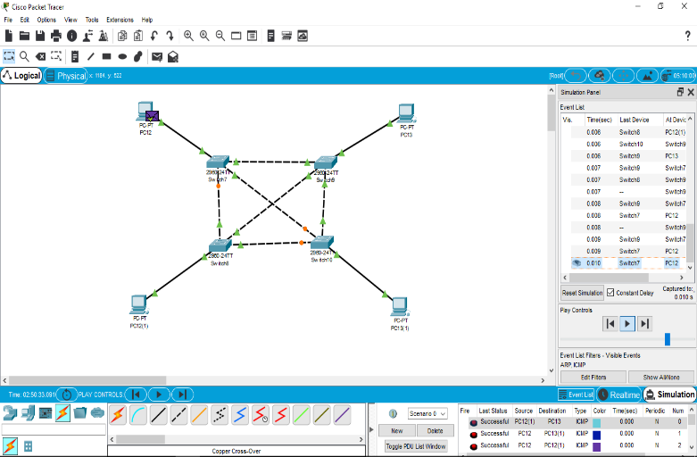

3

1. Data link layer trffic simulation using package tracer ( CSMA/CA &CSMA/CD )

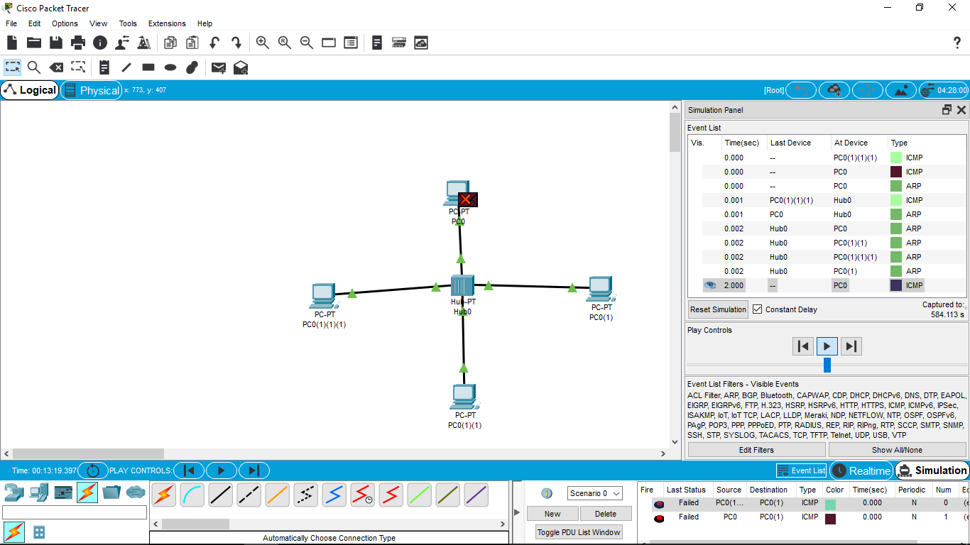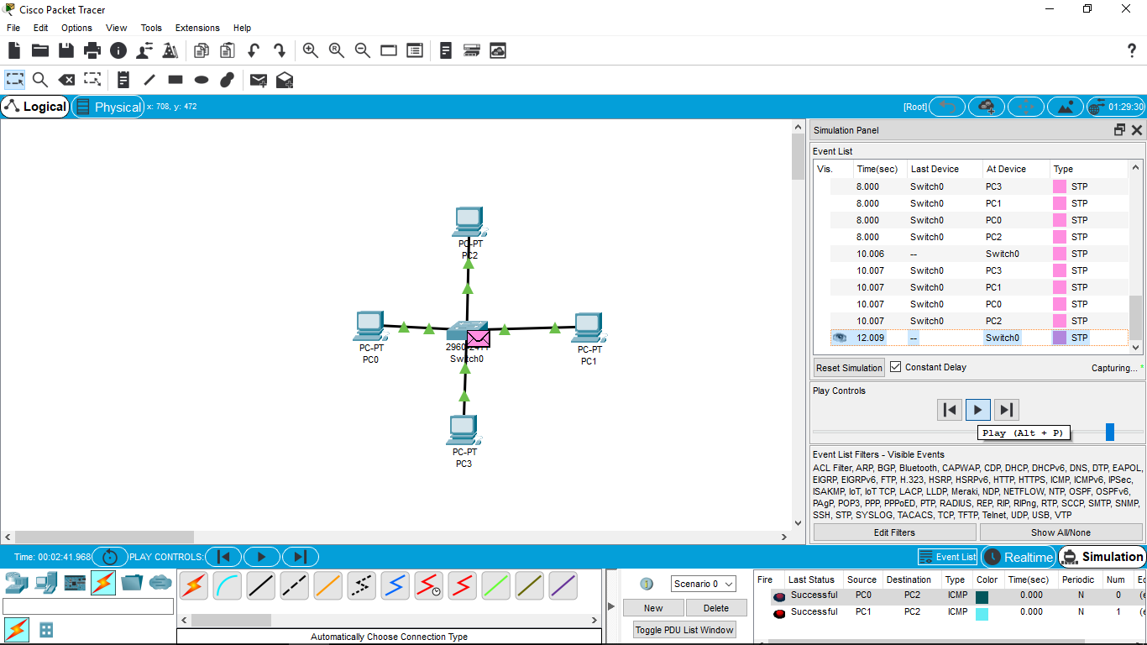

1. Data link layer traffic Simulation using package tracer using arp

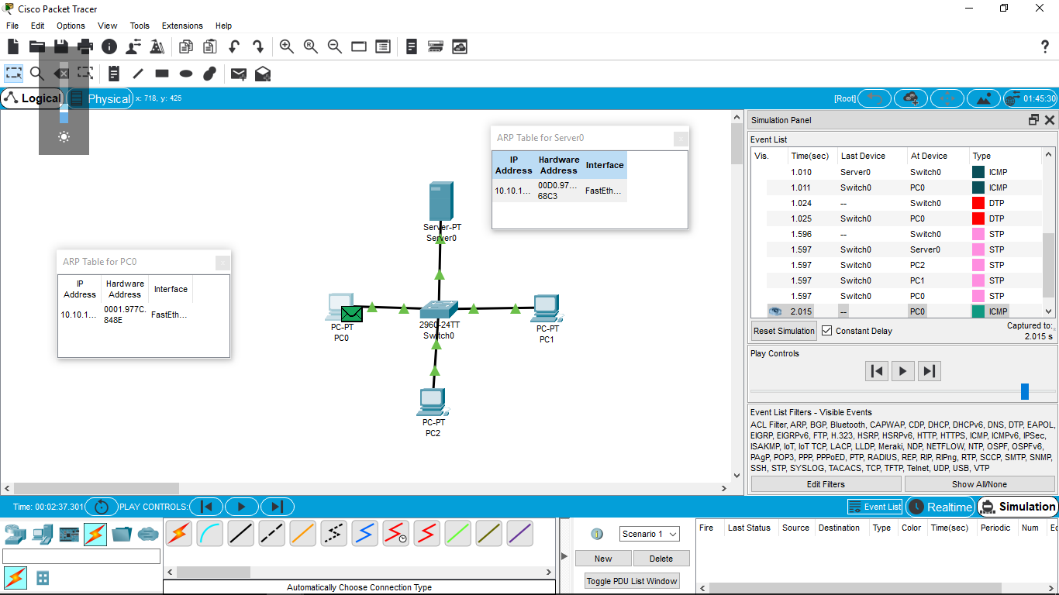

1. Static Router using pckage tracer.

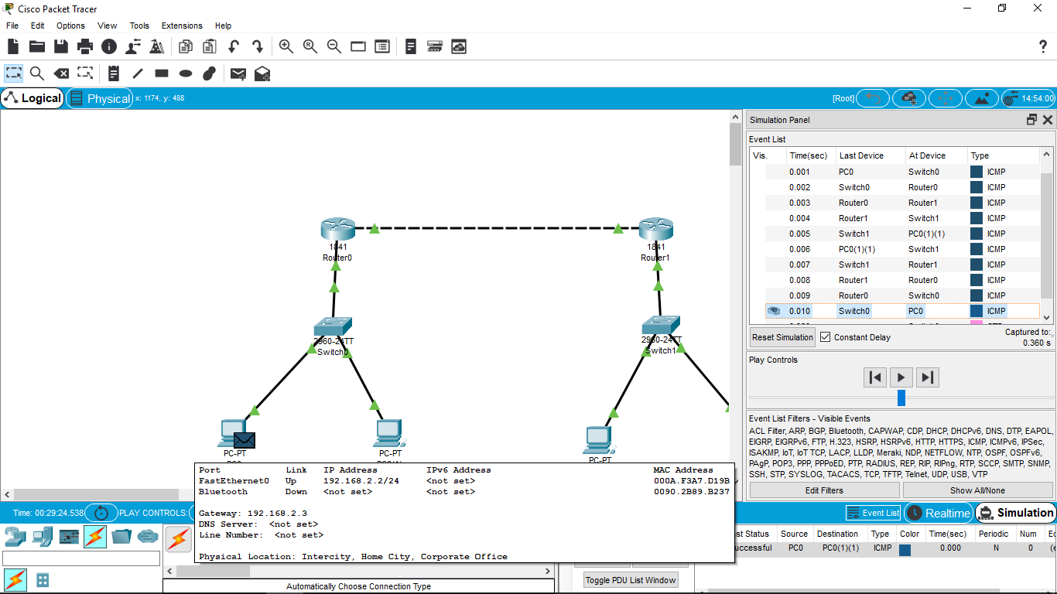

1. Dynamic Router using package tracer.

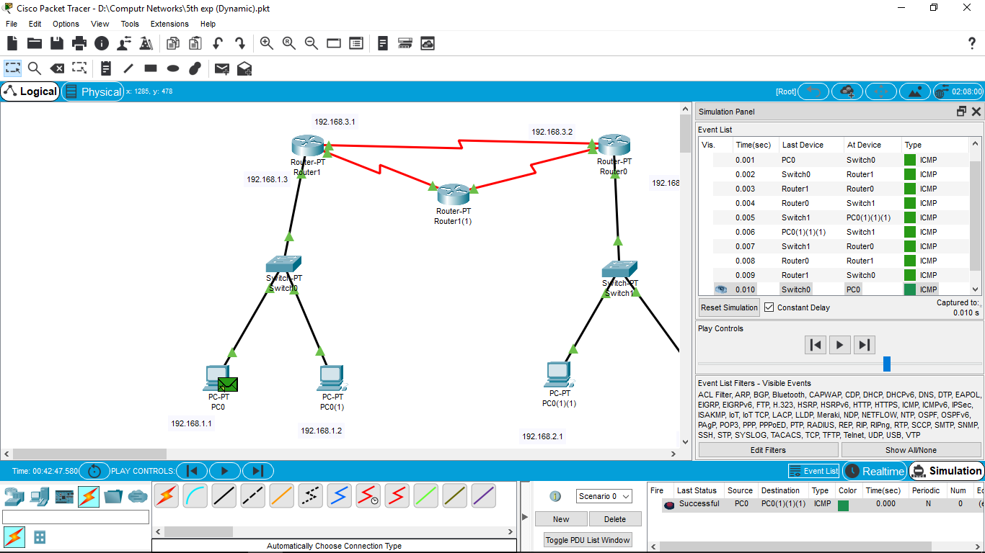

1. Subnetting –Class C Addressing

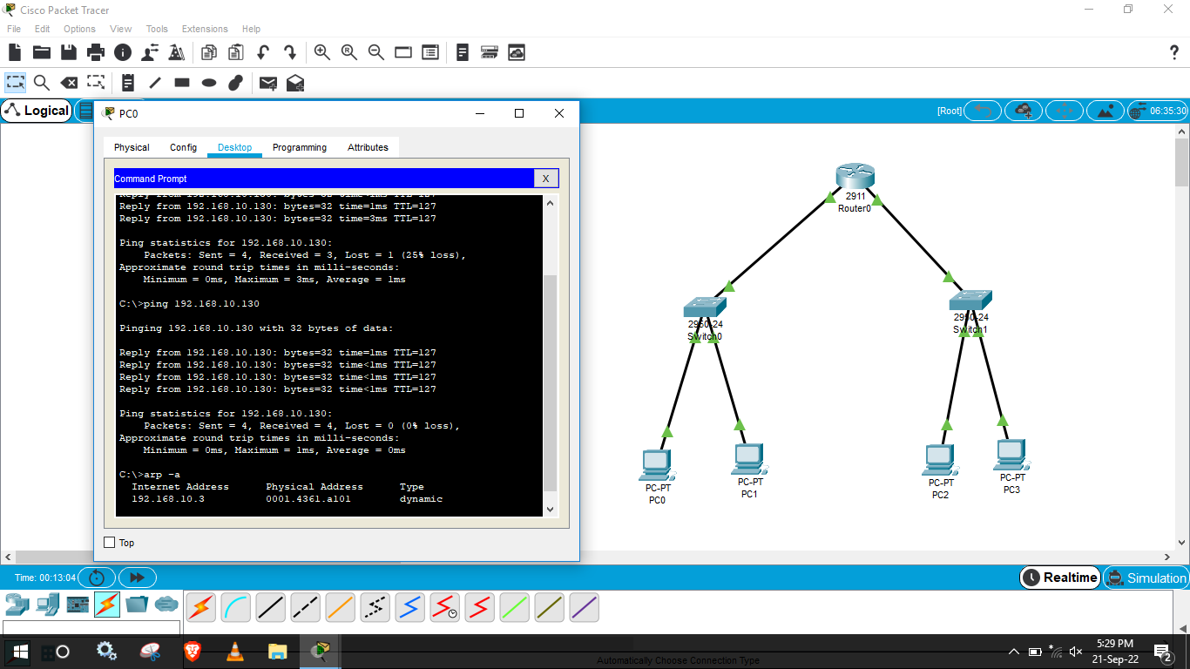

1. IOT Based Smart home using cisco package tracer

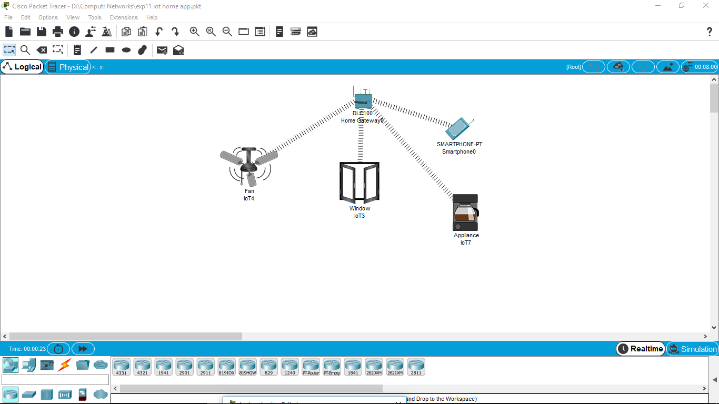

1. Smart garden in cisco package tracer.

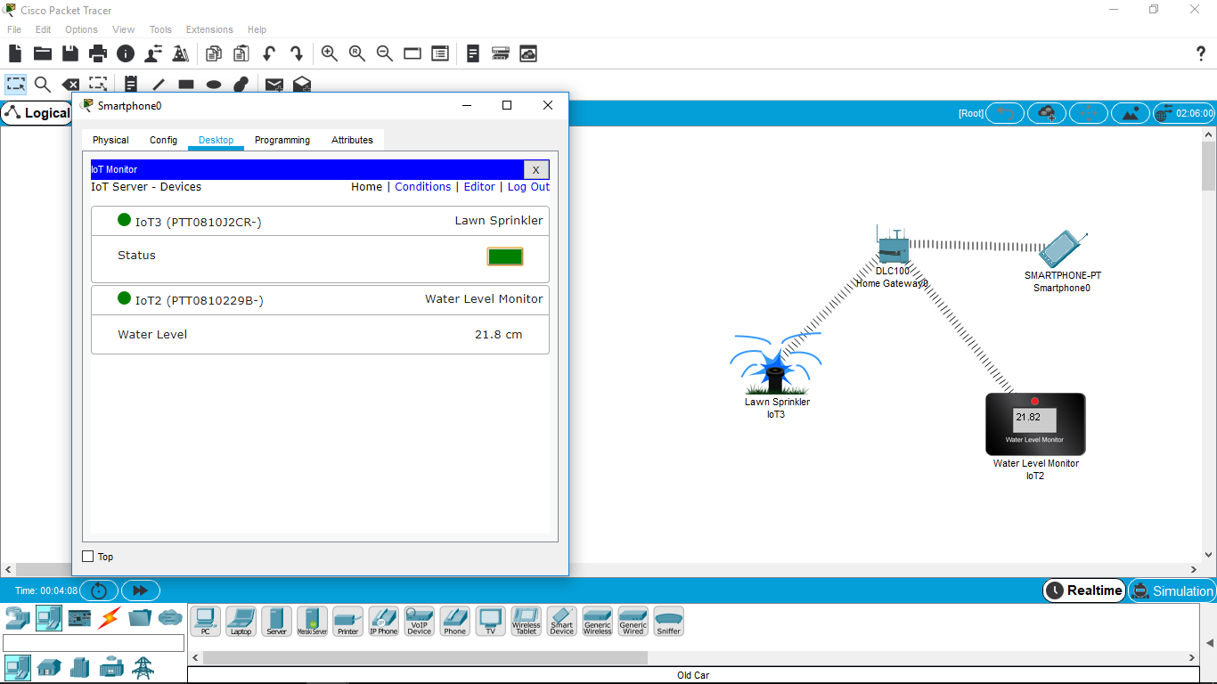

1. Make a Computer lab in cisco package tracer

